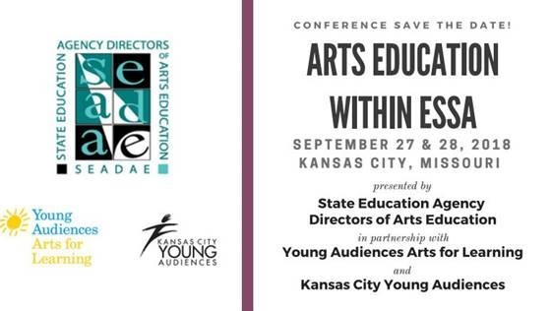
State Education Agency Directors of Arts Education and Young Audiences invite you to attend Arts Education within ESSA- a unique conference examining new realities in policy and practice since the historic passage of the Every Student Succeeds Act (ESSA).
Why attend?
Since the passage of ESSA, there have been many informational forums and professional development opportunities to learn about the facets of the law. This conference is unique in its focus on practice and policy under the new regulation. Arts Education Within ESSA offers a chance to examine the landscape of arts education today through the eyes of the practitioners.
Conference attendees will:
- participate in a national forum created to gather arts education experts, researchers, educators and practitioners
- experience models of arts education delivery at the national, state and local school district levels through the lens of ESSA
- engage in deep conversations comparing what is happening at a policy level to the “boots on the ground” view of the classroom
- hear from researchers and other arts stakeholders representing diverse perspectives and populations
- enjoy a unique chance for your program or state department of education’s voice to be heard
For your convenience this document includes a sample letter you can customize and use to request travel permissions; followed by some travel tips. Don’t miss this valuable opportunity for learning, sharing and expanding your knowledge side by side with some of the most brilliant minds in arts education today.

Dear (SUPERVISOR),

I am requesting your permission to attend the a conference entitled Arts Education Within ESSA, hosted by the State Education Agency Directors of Arts Education Arts Assessment, Young Audiences Arts for Learning and Kansas City Young Audiences in Kansas City, MO, September 27th and 28th, 2018. This conference will provide me with numerous professional development opportunities through workshops and discussion with my peers as arts educators, administrators, researchers, teaching artists and state level curriculum directors from all over the United States gather to share and network. A full conference schedule may be found here
The numerous sessions have been chosen to offer solutions to problems of practice common to my day to day work needs and professional life; helping me to expand my knowledge of the ways in which the new Every Student Succeeds Act might impact my work through the dual lens of both policy and practice. I look forward to this conference offering new ideas to expand my job knowledge for a direct impact on my constituency and my peers.
I have included a detailed cost breakdown of the conference for you to review.
I estimate the total cost of the conference will be (AMOUNT). If I am approved to attend the conference, the benefits to our organization are as follows:
∙ Time for networking with other seasoned arts educators and researchers from across the country.
∙ Ability to obtain fresh new creative ideas and techniques from experts in my field.
∙ Ability to gather a national perspective on the ways in which ESSA funding streams have been used to support students through the arts.
Thank you for taking the time out of your busy schedule to consider my request. I look forward to hearing from you and to represent our team at the Arts Education within ESSA conference in Kansas City, MO, September 27th and 27th, 2018. .
Sincerely, (YOUR NAME)

Travel Information
A limited bank of rooms have been reserved for us at a special conference rate of $119.00 per night at the Holiday Inn Country Club Plaza in Kansas City, MO.
Hotel Reservation Link
To research ways to pay the least amount for travel, try this fare comparison tool at Fare Compare.
Fare Comparison Advice

